Genesis Field Theory: A Spectral Emergent Cosmology Framework
Version: 1.2
Josiah Bessler
⚠️ This Document is Not Scientifically Verified.

Abstract
We present a unified spectral framework for cosmology known as Genesis Field Theory (GenesisFT), in which spacetime, matter, dark matter, time, and large-scale cosmic structure emerge from a deeper pre-geometric generative field defined over a compact configuration manifold Ξ. The theory provides a single operator Ô whose spectrum generates particle families, dark-matter halo structures, gravitational-wave echoes, and oscillatory corrections to the matter power spectrum P(k). This document consolidates the current spectral formulation, predictions, observational signatures, and mathematical architecture of GenesisFT developed to date into a single coherent proposal and research program.

Introduction
Genesis Field Theory (GenesisFT) proposes that all observable physical structures—including spacetime, matter fields, dark matter, and temporal flow—emerge from a deeper pre-geometric regime governed by a generative operator Ô acting on a compact configuration manifold Ξ. Unlike conventional approaches, GenesisFT does not start from spacetime but derives it as an emergent construct via correlation kernels and spectral geometry. The aim of this document is to present the current spectral formulation of GenesisFT as a rigorous, unified cosmological framework proposal, integrating dynamical emergence, spectral phenomenology, predictions, falsifiability tests, and mathematical foundations. This version also incorporates refined conceptual formulations, consolidated theory sections, and the fully reconstructed Appendix A. In the present work, we assume an effective FRW background and standard Newtonian gravitational coupling at large scales; deriving Lorentzian signature and Friedmann dynamics directly from the underlying spectral data is left for future work.

Relation to the Working Model.
This Overview presents Genesis Field Theory in its abstract spectral form, where the universe is described using a compact configuration space Ξ, a Laplace-type operator Ô = -Δ_Ξ + U, its eigenmodes χ_k, and an associated kernel K* whose spectrum {μ_k*} defines the stable configuration.
The companion document 'Genesis Field Theory – Working Model' presents the corresponding effective 3+1 dimensional field-theory realization. In that formulation, the same spectral structure appears through a real scalar field Φ(x,t) evolving under the Lagrangian L = 1/2 ∂_μΦ ∂^μΦ − 1/2 m^2Φ^2 − 1/2 Φ Ô_eff Φ − V(Φ), with Ô_eff = -∇² + V_eff(x).
Both documents describe the same underlying stability principle and spectral band structure (IR, MID, UV); the Working Model simply provides the effective spacetime description used for halo modeling, rotation-curve predictions, and gravitational analysis.
EMPIRICAL STATUS UPDATE (2026-07-04). Parts of the validation program described in this document have now been executed. (1) The λ → k, μ_k★ → Pζ mapping was run end-to-end through CAMB (December 2025) and tested against the Planck 2018 binned TT spectrum (July 2026). The oscillatory P(k) features highlighted in Figs. 10–11 and falsifiable prediction (1) are now quantitatively constrained: every tested configuration in which the operator spectrum measurably influences Pζ(k) is excluded (Δχ² ≥ +15,189 over 66 bins at coupling c = 1; bound c ≲ 0.047 at a₂ = 8000), and the Planck-consistent limit is identical to ΛCDM by construction. Any GenesisFT imprint on the primordial spectrum must be ≲ 0.6% rms. (2) The galaxy-scale predictions (cored halos with oscillatory shells, rotation-curve wiggles, lensing fine structure) are not affected by this bound and remain open. (3) The mid-band halo picture has been refined: the verified lensing-consistent MID-band eigenmode differs from the original UCP template (relative L2 ≈ 0.72); realistic halos are UV/MID/IR composites. (4) An early GenFT-vs-MOND comparison was retracted on methodological grounds and should not be cited. Code, data, reference outputs, and replication instructions: the reproducibility folder of this repository.

Core Assumptions of GenesisFT Model A
- Ξ is a compact Riemannian configuration manifold.
- The generative operator is Laplace-type, Ô = -Δ_Ξ + U, with discrete spectrum {λₖ, χₖ}. In the illustrative Model A used here, U is taken to be constant so that Ô reduces effectively to the bare Laplace–Beltrami operator.
- K(τ) is a positive Hilbert–Schmidt kernel operator evolving in meta-time τ via a stochastic gradient flow of a potential V[K].
- Under suitable regularity, coercivity, and convexity assumptions on V[K], a condensed fixed point K★ exists and is unique up to symmetries.
- In Model A we impose basis alignment [K★, Ô] = 0 so that K★ and Ô admit a common eigenbasis {χₖ} and spectral data (λₖ, μₖ★) can be paired mode by mode.
- An approximate emergent FRW-like metric on a coarse-grained spacetime manifold ℳ is reconstructed from the spectral data of K★ via a spectral distance construction.
- Spectral bands of condensed modes (large μₖ★) are interpreted as visible-sector degrees of freedom, while less-condensed bands (small μₖ★) form a mid-band (dark-matter band) sector that sources halos, lensing corrections, and additional effective energy density.

Emergent Spacetime and Metric Reconstruction
Genesis Field Theory (GenesisFT) posits that spacetime is not fundamental. The basic objects are a compact configuration manifold Ξ, a Laplace-type operator Ô acting on Ξ, and a correlation kernel K that encodes generalized field correlations. In Model A implementations, Ξ is taken to be a product manifold such as S³ × T³, and Ô is represented by a finite-dimensional Hermitian matrix in a truncated eigenbasis.
Let Ôχₖ = λₖχₖ define eigenpairs of the generative operator with discrete spectrum {λₖ}. A late-time condensed kernel K★ can then be written in the eigenbasis as K★ = ∑ₖ μₖ★ |χₖ⟩⟨χₖ|, where μₖ★ are kernel eigenvalues determined by an effective potential V[K] and noise dynamics (see Appendix A). The associated two-point correlation kernel C(x,y) ≃ ∑ₖ μₖ★ χₖ(x)χₖ*(y) plays the central geometric role. In what follows we assume that the late-time condensed kernel K★ commutes with Ô, so that they admit this common eigenbasis {χₖ}; this basis alignment is a structural assumption of the present GenesisFT Model A implementation.
An effective spectral distance between points x,y ∈ Ξ can be defined schematically as d²(x,y) ∼ ∑ₖ wₖ |χₖ(x) − χₖ(y)|², where the weights wₖ depend on μₖ★ and λₖ. In the continuum limit, and for sufficiently smooth spectra, this spectral distance induces a Riemannian metric g on a coarse-grained manifold ℳ. In the cosmological sector, ℳ is interpreted as an emergent spacetime manifold that approximates a 3+1 FRW geometry on large scales. The underlying spectral-distance framework and induced-metric construction are set up in Appendix A. For the purposes of the present work we adopt the following working assumption:
Assumption (Spectral FRW emergence). In Model A, the large-scale metric reconstructed from the spectral data of K★ via this distance is approximately homogeneous and isotropic and can be modeled by an effective FRW line element on a coarse-grained spacetime manifold ℳ. A full proof of this assumption would require showing that, under the GenesisFT dynamics, the low-lying spectral data of K★ converge toward those of a constant-curvature 3-geometry at large scales; establishing such a theorem is left for future work.
To obtain a 3+1 decomposition, we assume that K★ factorizes approximately into Kspace ⊗ Kclock at late times, where Kspace governs spatial correlations and Kclock encodes an emergent clock degree of freedom derived from the meta-time dynamics. Restricting the spectral distance to spatial coordinates yields an emergent spatial metric, while the evolution of K★ along the clock direction defines lapse and scale-factor data. Thus, in GenesisFT, the spacetime metric is reconstructed from the spectrum of Ô and the condensed kernel K★, rather than postulated a priori.

Spectral Decomposition into Matter and Dark Sectors
Genesis Field Theory distinguishes between condensed modes, associated with visible-sector matter, and uncondensed modes, associated with a mid-band (dark-matter band) sector. This distinction is encoded in the eigenvalues μₖ★ of the condensed kernel K★.
Modes with relatively large μₖ★ are interpreted as forming a condensate that behaves like effective matter fields. Their eigenvalues λₖ define mass scales via mₖ² = α λₖ for some universal scaling factor α. In the Model A code, this mapping is implemented by assigning effective masses to eigenvalues and fitting α so that small subsets of λₖ reproduce, to first approximation, known mass hierarchies such as the charged leptons. A more detailed discussion of this spectral mass mapping is given in Appendix A.
Modes with much smaller μₖ★ do not participate in the visible condensate. These uncondensed modes form the mid-band (dark-matter band) sector. At coarse-grained level, the full GenesisFT state can be decomposed schematically as Φ(x) = ∑ₖ∈vis aₖ χₖ(x) + ∑ₖ∈dark bₖ χₖ(x), where the first sum describes visible-sector excitations and the second sum encodes mid-band dark-matter structure. The mid-band contribution sources halo-like overdensities and subtle modifications to spacetime curvature, while remaining largely decoupled from visible matter except through gravity and effective metric effects.

Vacuum Transition and the Arrow of Time
The dynamics of K in meta-time τ are governed, at the conceptual level, by an effective functional V[K] and stochastic fluctuations. A simple schematic form is V[K] ∼ a₁ Tr K + a₂ Tr K² − b S[K], where S[K] plays the role of a spectral entropy functional S[K] := -∑_k μ_k ln μ_k and a₂ > 0 favors low-rank condensed configurations. The meta-time evolution is then approximated by a noisy gradient flow, dK/dτ = − δV/δK + η(τ), driving K toward a condensed vacuum K★.
This dynamics singles out a direction in meta-time: generic trajectories flow from high-complexity, nearly random kernels toward lower-complexity, more structured K★. The functional V[K] defines a Lyapunov-like quantity that decreases along typical trajectories, while the noise term η(τ) explores local configuration space without restoring the original high-complexity state. The result is an intrinsic arrow of time at the level of the kernel dynamics. The double-well sketches used elsewhere in the paper should be understood as effective potentials V(G) for coarse-grained order parameters G, whereas the functional V[K] governing the kernel flow is assumed strictly convex in a neighborhood of its minimum, so that the late-time condensed kernel K★ is unique.

Meta-time and Physical Time
Physical time t is then defined as the emergent parameter along which correlation length grows, the effective spatial metric becomes smoother, and energy flows from high-frequency modes into condensed low-frequency structures. In cosmological language, the Big Bang corresponds to the epoch at which the instability in V[K] drives a rapid transition toward condensation, and the subsequent expansion history tracks the continued relaxation and reconfiguration of spectral weight. More precisely, meta-time τ is the parameter of the stochastic gradient flow K(τ) governed by V[K], while physical time t is defined as a monotonic reparametrization chosen so that coarse observables such as correlation length, effective scale factor, or average energy density evolve smoothly in t and match standard FRW cosmic time at late epochs. In this paper we do not derive a unique mapping τ ↦ t from first principles; instead we treat t as a phenomenological clock extracted from the large-scale behavior of K(τ), consistent with the FRW background assumed at cosmological scales.

Cosmological Phenomenology
On large scales, Genesis Field Theory is designed to reproduce the key successes of ΛCDM while adding distinctive spectral signatures. The total energy density is decomposed into a visible part ρvis and a mid-band dark-matter part ρ_DF, so that ρtot = ρvis + ρ_DF. At coarse level the scale factor a(t) obeys a Friedmann-like relation H²(t) ≃ (8πG/3)[ρvis(t) + ρ_DF(t)] + Λeff/3, where Λeff arises from the low-λₖ spectral density of Ô. In this way, GenesisFT recovers an FRW-like background expansion with potentially small corrections.
The primordial power spectrum P(k) is built by mapping eigenvalues λₖ to effective comoving wavenumbers, kₖ ∼ √λₖ, and using kernel eigenvalues μₖ★ as seeds for mode amplitudes. A discrete set of (kₖ, μₖ★) pairs is then used to construct a toy primordial spectrum P(kₖ) ∝ μₖ★² (kₖ/k₀)^{n_s−1}, with n_s the spectral tilt. Interpolation onto a continuous k-grid yields P(k) suitable for comparison with standard cosmological predictions. As illustrated schematically in Fig. 10–11, the discrete spectrum of Ô produces mild oscillatory features superposed on a nearly power-law P(k). Operationally, the map proceeds in three steps: (i) eigenvalues λₖ are converted to effective comoving wavenumbers kₖ = κ √λₖ; (ii) each mode is assigned a primordial curvature amplitude proportional to μₖ★, so that P_ζ(kₖ) ∝ (μₖ★)²; and (iii) these discrete samples are interpolated to a continuous P(k) that can, in future work, be used as input to Boltzmann solvers such as CLASS or CAMB for comparison with CMB and large-scale-structure data.
Because the spectrum of Ô is discrete and structured, GenesisFT generically predicts mild oscillatory features in P(k) superposed on an almost power-law background. The frequency and amplitude of these oscillations are controlled by gaps and clustering in the eigenvalue spectrum λₖ. These signatures provide a concrete observational discriminator: precise measurements of the matter power spectrum and CMB lensing can, in principle, test the presence or absence of such GenesisFT-induced oscillations.
In the canonical GenesisFT Model A we fix the configuration manifold to be Ξ = S³(R_S) × T³(L₁,L₂,L₃) and take the generative operator to be of Laplace type. For the illustrative calculations in this paper we set the potential term to a constant (absorbed into the overall energy scale) so that, effectively, Ô reduces to the bare Laplace–Beltrami operator,
Ô = -Δ_Ξ,
where Δ_Ξ = Δ_S³ + Δ_T³ is the Laplace–Beltrami operator on Ξ. Eigenmodes are then products of spherical harmonics on S³ and toroidal plane waves on T³ with eigenvalues
λ_{ℓ,⃗n} = ℓ(ℓ+2)/R_S² + Σ_i (2π n_i / L_i)².
On such curved spaces the physical frequency of a massless mode is tied to √λ_k; in the FRW-like background we encode this in an effective comoving wavenumber mapping
k_k = κ √λ_k,
up to a curvature correction at low ℓ that slightly distorts the spectrum but does not affect the qualitative picture. This explicit specialization (constant U) makes clear that the quoted eigenvalues are those of the pure Laplacian; more general choices of U(x) would modify the spectrum and are left to future, more detailed models.
Given the condensed kernel K★ with eigenvalues μ_k★, primordial curvature perturbations are modeled as stochastic excitations of the corresponding modes. In Model A, the kernel relaxes under a potential
V[K] = a₁ Tr K + a₂ Tr K² + b Σ_k μ_k ln μ_k
driven by Gaussian colored noise in meta-time. At equilibrium this yields curvature perturbation amplitudes obeying
⟨|ζ_k|²⟩ ∝ (μ_k★)²,
so the primordial curvature power spectrum is
P_ζ(k_k) ∝ (μ_k★)²,
with the proportionality fixed by the observed scalar amplitude. The discrete set of points (k_k, P_ζ(k_k)) can then be interpolated and passed directly to standard Boltzmann codes (e.g. CLASS/CAMB) to generate CMB and matter power spectra. The oscillatory and curvature-induced features in P(k) that we highlight in Figs. 10–11 are concrete predictions of this λ → k and μ_k★ → P_ζ mapping.

Astrophysical Phenomenology
In the same Model A setting, mid-band dark-matter halos are constructed directly from the uncondensed spectrum. One selects a band of modes in the dark sector (typically those with relatively small μ_k★ and long effective wavelengths) and forms an effective radial profile by projecting the eigenfunctions into a spherically averaged basis. The mid-band dark-matter energy density is then modeled as
ρ_DF(r) ∝ Σ_{k∈band} μ_k★ |φ_k(r)|²,
where φ_k(r) are the radial mode functions obtained from χ_k(x) on Ξ. Because the modes are discrete and oscillatory, ρ_DF(r) automatically combines a finite-density core with gently damped oscillations at larger radii. The associated circular velocity profile v_c(r) = √[G M(r)/r] thus exhibits flat rotation curves with small superposed wiggles, providing the template halo and rotation-curve phenomenology sketched in Figs. 8–10 and explored numerically in the Model A halo pipeline. In summary, the halo-construction pipeline consists of: (i) selecting an eigenvalue band interpreted as the dark sector, (ii) computing the corresponding radial mode functions φ_k(r), (iii) forming ρ_DF(r) from the weighted mode sum, and (iv) deriving circular velocities v_c(r) = √[GM(r)/r] and lensing deflections from this profile; toy realizations of these steps underlie the halo and rotation-curve plots shown in Figs. 8–10.
This procedure naturally yields cored central density profiles together with oscillatory shells in ρ(r) and corresponding wiggles in v_c(r). These features offer a potential explanation for observed deviations from simple cuspy profiles and provide testable predictions for high-resolution rotation-curve data.
Small-scale lensing phenomenology is also affected. The same mid-band dark-matter structures that shape ρ(r) induce modest, scale-dependent corrections to the lensing deflection angle α(b) as a function of impact parameter b. Toy models based on GenesisFT halos predict slight non-monotonic deviations from smooth NFW-like deflection profiles, particularly in strong-lensing systems with precise mass reconstructions. The resulting oscillatory corrections to deflection profiles are depicted conceptually in Figs. 13–14.
In regions of high mid-band dark-matter density ρ_DF, GenesisFT predicts changes in effective local clock rates. A simple relation of the form
Δt_local ∝ 1 / (1 + β ρ_DF)
captures the idea that dense dark configurations slightly slow local clocks relative to a cosmological reference. Such effects could, in principle, be probed using precision timing in dark-matter-rich environments. This relation should be understood as a phenomenological ansatz inspired by the spectral framework, rather than a uniquely derived prediction of GenesisFT; in particular, the parameter β and the precise functional dependence on ρ_DF are to be constrained by, and possibly adjusted in light of, precision timing data.
Finally, GenesisFT suggests a natural mechanism for gravitational-wave spectral echoes. Compact objects embedded in a GenesisFT mid-band dark-matter background experience modified effective potentials for perturbations. The discrete spectral structure of Ô implies a tower of quasi-normal-like modes, and the excitation of these modes during mergers can imprint late-time echoes and spectral peaks on gravitational-wave signals. Although full simulations remain future work, the qualitative expectation is that GenesisFT-like structure can generate echo phenomenology broadly consistent with the conceptual waveforms depicted in the figures. The qualitative quasi-normal mode ladder and echo-enriched waveforms appear in Figs. 15–17. In the present work this echo phenomenology is developed only at a qualitative level: we do not yet derive an explicit effective 1D potential or solve the full wave equation for perturbations in a GenesisFT background, and no matched-filter templates are constructed. The discussion here should therefore be read as outlining a mechanism and a class of possible signatures, to be made quantitative in future simulations.

Predictions and Falsifiability
Collecting the main observational consequences, Genesis Field Theory in its Model A realization makes several falsifiable predictions:
(1) The matter power spectrum P(k) should exhibit small-amplitude oscillatory features around a nearly power-law background, with frequencies tied to gaps in the eigenvalue spectrum λₖ. High-precision large-scale structure and CMB lensing measurements can test this prediction.
(2) Dark-matter-dominated halos should prefer cored central density profiles with mild oscillatory shells, yielding small but characteristic wiggles in rotation curves. High-resolution kinematic data from dwarf galaxies and low-surface-brightness galaxies can probe these features.
(3) Gravitational lensing deflection profiles in strongly lensed systems should show slight, scale-dependent deviations from smooth NFW-like behavior, traceable to underlying mid-band dark-matter oscillatory structure.
(4) Precision timing experiments in regions of high inferred dark-matter density may detect systematic clock-rate offsets consistent with mid-band dark-matter-induced time-dilation effects.
(5) Gravitational-wave signals from compact-object mergers may exhibit late-time echoes and spectral modulations linked to discrete mode structures associated with Ô and the mid-band environment.
For any fixed choice of operator Ô, kernel potential V[K], and parameter set (such as a specific implementation of Model A), the five classes of signatures above lead to quantitative predictions that can in principle be ruled out by sufficiently precise data. In this sense particular realizations of Genesis Field Theory are falsifiable. The broader spectral framework should therefore be regarded as a structured proposal and research program whose concrete instantiations may either survive or be excluded as the observational and numerical tests outlined above are carried out.

Numerical Model A Pipeline and Data Products
A concrete numerical realization of Genesis Field Theory, referred to as Model A, is implemented as a companion code base and summarized in Appendix B. In brief, the pipeline constructs a truncated representation of the operator Ô on Ξ = S³ × T³, computes its eigenvalues and kernel amplitudes, maps them to comoving wavenumbers and a primordial spectrum P_ζ(k), and generates illustrative mid-band dark-matter halo profiles and rotation curves. Appendix B describes this numerical implementation and its extension path toward full Boltzmann and structure-formation analyses in more detail.

Discussion
Genesis Field Theory, as developed here, sits at the intersection of several major lines of work in fundamental physics and cosmology. Like ΛCDM, it accepts the broad observational picture of an expanding Universe with dark matter and dark energy, but it differs at a deeper level by treating spacetime and matter as emergent from spectral data of a generative operator Ô on a compact configuration manifold. In this respect it is closer in spirit to emergent-spacetime and spectral-geometry approaches, yet it proposes a single operator and kernel as the common origin of geometry, matter, and dark sectors.
In comparison with modified-gravity models, GenesisFT does not postulate new long-range forces or ad hoc potential terms in the low-energy action. Instead, deviations from General Relativity and ΛCDM arise indirectly through the structure of the spectrum λₖ and the way mode weights μₖ★ populate condensed and mid-band (dark-matter band) sectors. This leads to qualitatively distinct signatures, such as oscillatory features in the matter power spectrum and halo profiles, that cannot easily be mimicked by smooth parameter deformations of ΛCDM.
At the same time, the present formulation is intentionally modest in its quantitative claims. The numerical Model A implementation uses finite-dimensional truncations, toy halo eigenfunctions, and simplified mappings from eigenvalues to cosmological scales. No full Boltzmann code, N-body simulation, or detailed parameter fit has been implemented yet. The focus has been to demonstrate that a single spectral framework can, in principle, generate the kinds of structures we observe: FRW-like expansion, dark-matter-like halos, small oscillatory corrections to P(k), and plausible echo phenomenology in gravitational waves. In particular, the present work still imposes an effective Lorentzian FRW background and Newton's constant G at the large-scale level; deriving Lorentzian signature and Friedmann dynamics directly from the underlying Riemannian spectral data remains an open problem for future development of GenesisFT.
Conceptually, GenesisFT has far-reaching implications. If correct even in outline, it suggests that what we call spacetime, fields, and particles are manifestations of a deeper spectral organization, and that the arrow of time is tied to the relaxation of a kernel in an abstract configuration space rather than to fundamental time-reversal symmetry breaking at the level of microdynamics. These ideas connect naturally to broader discussions about the ontology of time, the meaning of locality, and the status of the continuum in fundamental physics.

Conceptual Problems Addressed by GenesisFT
While the focus of this paper is on formulating Genesis Field Theory (GenesisFT) and outlining its phenomenology, it is useful to indicate the main conceptual problems it is intended to address.
Big Bang singularity and initial conditions. In classical FRW cosmology, extrapolating backward in time leads to a curvature singularity and an unexplained, extremely low-entropy initial state. In GenesisFT, the Big Bang is naturally reinterpreted as a vacuum transition in the kernel dynamics: a noisy gradient flow in operator space drives a pre-geometric, high-complexity kernel K(τ) toward a condensed fixed point K★. Spacetime and its metric emerge only after this transition, so the classical singularity is replaced by a phase change in the underlying spectral data rather than a literal divergence of curvature.
Arrow of time and low initial entropy. The same kernel dynamics naturally defines an arrow of time. The potential V[K] acts as a Lyapunov-like functional that decreases along typical trajectories of the stochastic gradient flow, and physical time t is identified with the direction in which correlation length grows and the condensed kernel K★ is approached. In this picture, the low “initial” entropy of the Universe reflects the low correlation and pre-condensed nature of the primordial kernel rather than a finely tuned boundary condition imposed by hand.
Nature and internal structure of dark matter halos. In ΛCDM, dark matter is usually modeled as an additional collisionless component whose microphysical origin is unspecified and whose small-scale structure can lead to tensions such as the core–cusp problem. In GenesisFT, dark matter corresponds to the mid-band spectral modes of the generative operator Ô in the spectrum of the generative operator Ô: a mid-band (dark-matter band) sector built from discrete long-wavelength eigenmodes. Cored, mildly oscillatory halo profiles and corresponding wiggles in rotation curves arise directly from the spectral construction ρ_DF(r) ∝ Σ_k μ_k★ |φ_k(r)|², rather than from ad hoc modifications of the low-energy action. This provides a concrete candidate mechanism for cored halos within a single spectral framework.
Unified origin of visible matter, dark sectors, and effective vacuum energy. Standard cosmology treats visible matter, dark matter, and dark energy as distinct ingredients added to the Einstein equations. In GenesisFT, the same spectral data (λ_k, μ_k★) of Ô and K★ underlie geometry, visible-sector condensates, mid-band dark-matter structure, and an effective cosmological term Λ_eff. Although the present work does not attempt to compute the observed value of Λ, it demonstrates how these components can, in principle, share a common spectral origin rather than being introduced separately.
These conceptual motivations should be understood as guiding principles rather than as fully resolved problems: in all cases, the present paper offers a coherent mechanism and framework, while detailed quantitative confrontation with data is deferred to the program outlined in the “Program for Full Cosmological Validation” section.

Program for Full Cosmological Validation
The limitations summarized above naturally define a concrete research program by which Genesis Field Theory can be promoted from a qualitative framework to a quantitatively tested cosmological model. Here we sketch the key work packages required for full validation and for extending GenesisFT toward a more complete physical theory.
(1) Boltzmann-level cosmology and data fitting. The first task is to take GenesisFT-derived primordial spectra and background histories and feed them into established Boltzmann solvers such as CLASS or CAMB. Concretely, one must (i) compute a sufficiently dense set of eigenvalues λₖ and kernel amplitudes μₖ★ for a chosen Model A parameter set, (ii) construct a smooth primordial curvature spectrum P_ζ(k) on the k-grid expected by the Boltzmann code, (iii) choose an effective background expansion history consistent with the GenesisFT energy densities, and (iv) run Markov-chain or nested-sampling parameter estimation against CMB, BAO, and large-scale-structure data. The goal is to determine whether there exist GenesisFT parameter regions that match current data at least as well as ΛCDM while retaining distinctive oscillatory signatures.
(2) Structure formation in the mid-band (dark-matter band) sector. In parallel, one should develop N-body or semi-analytic structure-formation simulations in which the mid-band (dark-matter band) sector evolves according to effective equations derived from the GenesisFT kernel. The halo-building recipes used here provide initial conditions and intuition, but a full assessment requires evolving the dark sector in an expanding background, computing halo mass functions, clustering statistics, and substructure properties, and comparing these with ΛCDM benchmarks. This will determine whether the cored and oscillatory halos predicted by GenesisFT are compatible with the observed population of galaxies and clusters.
(3) Toward a particle-physics layer. A third work package focuses on extending GenesisFT from a cosmological framework to a candidate underpinning for particle physics. This involves identifying spectral clusters and symmetry structures in the spectrum of Ô that can be associated with gauge groups, matter representations, and interaction terms. The simple mass relation mₖ² = α λₖ used here is only a starting point; a full theory will need to explain gauge charges, mixing angles, and interaction strengths, and to show how an effective low-energy Lagrangian resembling (or generalizing) the Standard Model emerges from the spectral data.
(4) Gravitational-wave echoes and timing phenomenology. Finally, GenesisFT predicts that discrete spectral structure and mid-band dark-matter environments can imprint late-time echoes and dispersive effects on gravitational waves, as well as small time-dilation anomalies in regions of high mid-band dark-matter density. A complete treatment calls for constructing explicit one-dimensional effective potentials for perturbations around GenesisFT-inspired compact objects, computing quasi-normal mode spectra, and generating waveform templates that can be searched for in LIGO/Virgo/KAGRA data. In parallel, one can model mid-band dark-matter time-dilation effects in concrete astrophysical settings and compare with precision timing experiments, such as pulsar timing arrays or clock networks.
Each of these work streams is substantial, but all are technically well-defined and build directly on the operator, kernel, and spectral structures already specified. Together they chart a clear path from the present framework-and-toy-numerics stage of Genesis Field Theory to a fully fledged, quantitatively testable cosmological and physical theory. An important open question is whether the commuting relation [K★, Ô] = 0 can be derived from a more fundamental choice of V[K], or whether it represents a fine-tuned structural simplification of Model A; at present it is postulated rather than derived.

Effective Field-Theory Working Model (Summary)
For practical galactic and cosmological calculations, Genesis Field Theory admits an effective description in terms of a real scalar Genesis Field Φ(x,t) living on 3+1 dimensional spacetime. In the companion Working Model, Φ(x,t) is governed by a Lagrangian of the form
L = 1/2 ∂_μΦ ∂^μΦ − 1/2 m^2Φ^2 − 1/2 Φ Ô_eff Φ − V(Φ),
with Ô_eff = -∇² + V_eff(x) a Laplace-type operator encoding the same spectral information as the abstract operator Ô used throughout this Overview. The corresponding field equation combines standard wave propagation, an effective mass scale, spectral band structure, and possible self-interactions.
In this effective picture, the mid-band (dark-matter band) modes of Ô_eff behave as a coherent dark sector that sources cored and mildly oscillatory halos, lensing corrections, and potential time-dilation effects, while the IR band shapes large-scale geometry and the UV band contributes high-frequency microstructure. The Working Model thus provides the concrete spacetime realization of the spectral GenesisFT framework summarized in this document.

Conclusion
In this work we have assembled Genesis Field Theory into a single, coherent spectral cosmology framework proposal. Starting from a compact configuration manifold Ξ, a generative operator Ô, and a correlation kernel K(τ), we showed how spacetime can emerge as a spectral-geometric construct, how visible and dark sectors arise from the distribution of kernel eigenvalues μₖ★, and how a meta-time vacuum transition endows the Universe with a natural arrow of time.
Building on this foundation, we outlined a phenomenology that spans cosmological and astrophysical scales. In the cosmological sector, GenesisFT can reproduce FRW-like background expansion while predicting small oscillatory features in the matter power spectrum P(k). In the astrophysical sector, uncondensed mid-band dark-matter modes generate cored and mildly oscillatory halos, subtle lensing corrections, mid-band dark-matter time-dilation effects, and a natural mechanism for gravitational-wave spectral echoes. The qualitative quasi-normal mode ladder and echo-enriched waveforms appear in Figs. 15–17.
The present implementation remains at the level of carefully constructed toy models and finite-dimensional numerics. Nevertheless, it provides a concrete proof of concept that a single spectral framework can account qualitatively for multiple seemingly unrelated phenomena. The next steps are clear: develop more realistic operators and kernels, couple GenesisFT-derived P(k) into full Boltzmann codes, perform parameter estimation against large-scale-structure and CMB data, and refine halo and lensing predictions for comparison with high-quality galactic and strong-lensing observations. The present work should therefore be viewed as a spectral framework and concrete Model A proposal, not yet a fully constrained cosmological model; many of the key assumptions highlighted here (basis alignment, large-scale FRW background, and the smallness of oscillatory amplitudes) remain to be tested quantitatively against data.
Whether or not Genesis Field Theory ultimately survives detailed confrontation with data, it illustrates a coherent path from abstract spectral structures to the rich phenomenology of our Universe. In that sense it serves both as a candidate theory and as a conceptual bridge between mathematical spectral geometry and observational cosmology.

Appendix A: Mathematical Architecture of Genesis Field Theory
Version 3.1 — Structured Mathematical Formulation. Representative schematic examples of the eigenvalue spectrum and mass-scaling relations are shown in Figs. A1–A2.
Abstract
We present a mathematically structured formulation of Genesis Field Theory (GenesisFT). The theory is built on a compact Riemannian manifold Ξ, a Hilbert space of fields L²(Ξ), a positive Hilbert–Schmidt kernel operator K(τ), and a stochastic gradient-flow evolution in operator space. We state explicit assumptions under which fixed points K★ exist, admit discrete spectra, and provide a complete orthonormal basis of eigenmodes. These eigenmodes constitute the fundamental degrees of freedom from which cosmological and particle-physics observables will be derived in subsequent papers.
1. Configuration Space and Measure
Assumption 1 (Configuration manifold). The underlying configuration space Ξ is assumed to be a compact, connected, oriented, smooth Riemannian manifold of dimension D ≥ 3 equipped with metric g_ab. Compactness ensures that Laplace-type operators on Ξ admit purely discrete spectra with finite multiplicities.

The Riemannian metric g_ab induces a natural volume measure dμ_g(x), which we denote simply by dμ(x). Integration of scalar functions over Ξ is always taken with respect to this measure.
2. Functional Setting
Definition 2.1 (Hilbert space of fields). The generative field 𝓖 and all derived scalar fields live in the Hilbert space L²(Ξ, dμ), defined as the set of (equivalence classes of) square-integrable complex-valued functions on Ξ with inner product ⟨f,g⟩ = ∫_Ξ f(x) g*(x) dμ(x). This space is complete and separable.
Definition 2.2 (Sobolev spaces). For k ≥ 1, we denote by H^k(Ξ) the Sobolev space consisting of L² functions whose weak derivatives up to order k are also in L². These spaces provide natural domains for differential operators.
3. Kernel Operator K
Definition 3.1 (Kernel). At each generative time τ, the kernel K(τ) is a linear operator K(τ): L²(Ξ) → L²(Ξ) admitting an integral kernel representation K(τ;x,y) such that, for all f ∈ L²(Ξ),

Assumption 3.2 (Hilbert–Schmidt). For each τ, K(τ;x,y) is square-integrable on Ξ×Ξ, making K(τ) a Hilbert–Schmidt operator. In particular, K(τ) is compact. Self-adjointness is imposed by the symmetry condition K(τ;x,y) = K(τ;y,x)* almost everywhere.
Assumption 3.3 (Positivity). K(τ) is assumed positive semidefinite, i.e. ⟨f, K(τ) f⟩ ≥ 0 for all f ∈ L²(Ξ). Later, strict positivity of some modes will correspond to physically realized excitations.
4. Generative Operator Ô and Spectral Basis
We introduce a second linear operator Ô acting on a suitable dense domain D(Ô) ⊂ L²(Ξ), modeled as a Laplace-type operator plus a bounded potential term:

Assumption 4.1 (Ellipticity and self-adjointness). Ô is taken to be essentially self-adjoint on C^∞(Ξ), elliptic, and bounded from below. On a compact manifold, these conditions guarantee a pure point spectrum {λ_k} with λ_k → +∞ and a complete orthonormal basis of eigenfunctions {χ_k} in L²(Ξ).
The operator Ô provides a canonical “mode” basis independent of K(τ). In many constructions, we align the eigenfunctions φ_k of K★ with those of Ô, or at least express φ_k in this basis. The eigenvalues λ_k play a key role in defining particle masses and other physical scales.
5. Potential V[K] and Gradient Flow
The evolution of K(τ) is governed by a variational principle in the infinite-dimensional space of Hilbert–Schmidt kernels. We define a functional V[K] on the space of admissible operators, typically of the schematic form V[K] = V_trace[K] + V_nonlinear[K], where the first term encodes spectral penalties and the second encodes nonlinear interactions.
Postulate 5.1 (Gradient flow with noise). The generative dynamics are given by an operator-valued stochastic differential equation:

Here δV/δK denotes the Fréchet derivative of V with respect to K in the Hilbert–Schmidt norm, and η(τ) is a Gaussian operator-valued noise with mean zero and covariance specified by a kernel N(x,y) via ⟨η(τ;x,y) η(τ';u,v)⟩ = N[(x,y),(u,v)] δ(τ−τ').
Assumption 5.2 (Regularity of V). V is assumed to be Fréchet differentiable, bounded from below, and strictly convex in a neighborhood of its minima. These conditions are sufficient to ensure existence and uniqueness (up to equivalence) of minima and to control the long-time behavior of the deterministic part of the flow.
6. Fixed Points and Existence of K★
In the absence of noise, fixed points K★ are defined by the condition that the gradient of V vanishes:

Proposition 6.1 (Existence of fixed points). Suppose V is coercive in the Hilbert–Schmidt norm (i.e. V[K] → +∞ as ∥K∥_{HS} → ∞) and lower semicontinuous. Then V attains its minimum on the closed convex set of admissible kernels, and any minimizer K★ satisfies δV/δK|_{K★} = 0 in the sense of distributions, hence defines a fixed point of the deterministic gradient flow.
If V is strictly convex, the minimizer K★ is unique. In the full stochastic setting, the long-time distribution of K(τ) is then sharply peaked around K★.
7. Spectral Theorem and Eigenmode Decomposition
Because K★ is self-adjoint, positive, and compact, the spectral theorem applies. Thus there exists a sequence of non-negative eigenvalues {μ_k} with μ_k → 0 and an orthonormal basis of eigenfunctions {φ_k} such that:
Assumption 7.1 (Basis alignment). In the phenomenological constructions of the main text we assume that the condensed kernel K★ commutes with the generative operator Ô, so that a common eigenbasis {χₖ} can be chosen and the spectral data (λₖ, μₖ★) may be paired mode by mode. This is a structural assumption of Model A rather than a theorem, and more general non-commuting cases are left for future work.

For any f ∈ L²(Ξ), we may write the action of K★ in its eigenbasis as:

The coefficients ⟨f, φ_k⟩ are the usual Hilbert-space projections. This expansion is absolutely convergent for all f ∈ L²(Ξ). The pair ({μ_k}, {φ_k}) is what we refer to as the eigenmode spectrum of the generative kernel.
A schematic eigenvalue spectrum is illustrated below:

8. Relation to Physical Scales and Mass Spectrum
A central hypothesis of GenesisFT is that a subset of the eigenvalues {λ_k} of the operator Ô can be mapped to particle masses via a universal scaling relation. We posit the existence of a constant α with dimensions of mass squared such that, for appropriate modes k,

Here λ_k are understood as eigenvalues of Ô or an associated dimensionless operator; α then fixes the absolute mass scale. It follows that any mass ratio is determined by the ratio of eigenvalues: m_i/m_j = sqrt(λ_i/λ_j). In later papers, this relation will be constrained against empirical particle spectra. In the present work, we simply formalize the eigenvalue problem well enough that such comparisons are meaningful.
9. Summary of Mathematical Assumptions
We summarize the key assumptions required to make GenesisFT mathematically sound and predictive:
1. Ξ is a compact, connected, smooth Riemannian manifold.
2. Fields live in the Hilbert space L²(Ξ) and appropriate Sobolev spaces.
3. K(τ) is a positive, self-adjoint, Hilbert–Schmidt operator for all τ.
4. Ô is an elliptic, essentially self-adjoint Laplace-type operator with discrete spectrum.
5. The potential functional V[K] is Fréchet differentiable, coercive, and (locally) strictly convex.
6. The stochastic gradient flow converges in distribution to a neighborhood of a unique fixed-point kernel K★.
7. The eigenmode spectrum ({μ_k}, {φ_k}) of K★ is complete and forms the backbone of all emergent physics.
Under these conditions, GenesisFT has a solid mathematical foundation suitable for the cosmological and particle-physics developments that will be carried out in subsequent papers in this series.

Appendix B: Numerical Implementation and Toy Data (Model A)
This appendix summarizes the numerical realization of Genesis Field Theory used to generate the illustrative spectra, primordial power curves, and halo profiles discussed in the main text. The reference implementation ("Model A pipeline") consists of a set of Python modules that:
• construct truncated matrix representations of Ô = -Δ_Ξ + U on Ξ = S³ × T³,
• compute eigenvalues λ_k and eigenvectors χ_k,
• evaluate kernel eigenvalues μ_k★ from a potential V[K] = a₁ Tr K + a₂ Tr K² + b Σ_k μ_k★ ln μ_k★ with noise-driven evolution,
• map λ_k → k_k via k_k = κ √λ_k with curvature corrections at low l,
• build a discrete primordial curvature spectrum P_ζ(k_k) ∝ (μ_k★)²,
• and construct toy mid-band dark-matter halo profiles ρ_DF(r) ∝ Σ_k μ_k★ |φ_k(r)|² and their rotation curves.
For clarity and portability, the present document does not embed the full numerical tables or code listings. Instead, the accompanying source files (e.g. modelA_spectrum.py, modelA_pk.py, modelA_halo.py, modelA_massfit.py, modelA_optimize.py, GenesisFT_model_a.py) implement the algorithms described here. They enable direct generation of eigenvalue spectra, primordial P(k) samples, and halo density/velocity profiles that correspond to the conceptual Figures 8–11 and 15–17. Future releases may promote this appendix to a full data companion, including calibrated parameter sets and best-fit comparisons to specific CMB and large-scale-structure datasets.

Figures
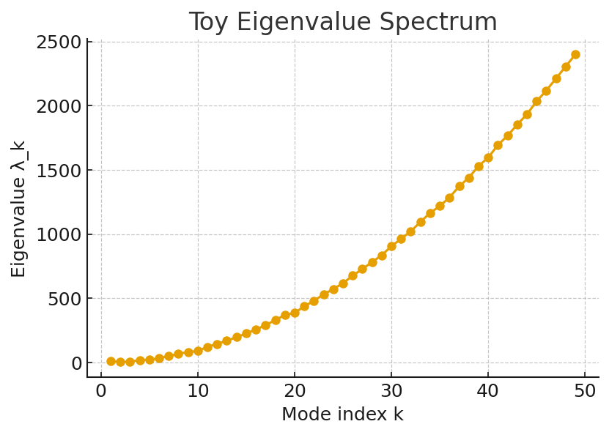
Fig. 1. Toy eigenvalue spectrum λₖ as a function of mode index k for the generative operator Ô. This demonstrates discrete spectral structure on a compact Ξ.
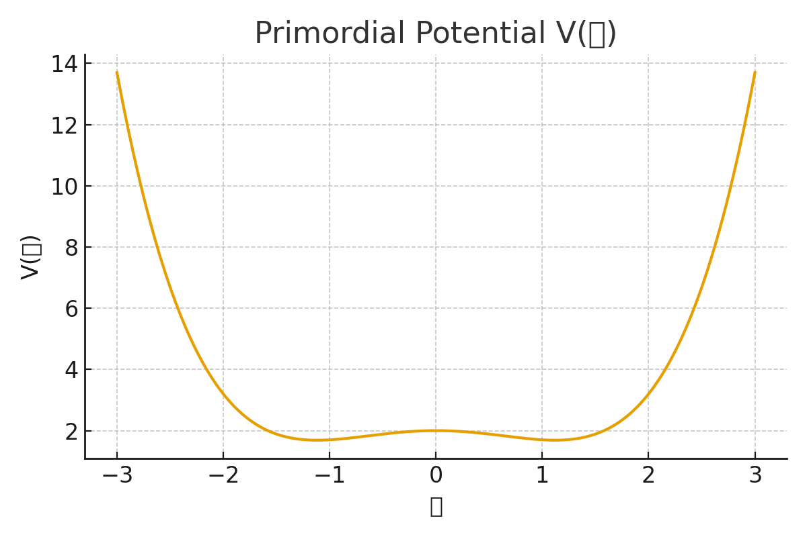
Fig. 2. Conceptual potential landscape V(𝒢) showing unstable primordial and stable condensed vacua.
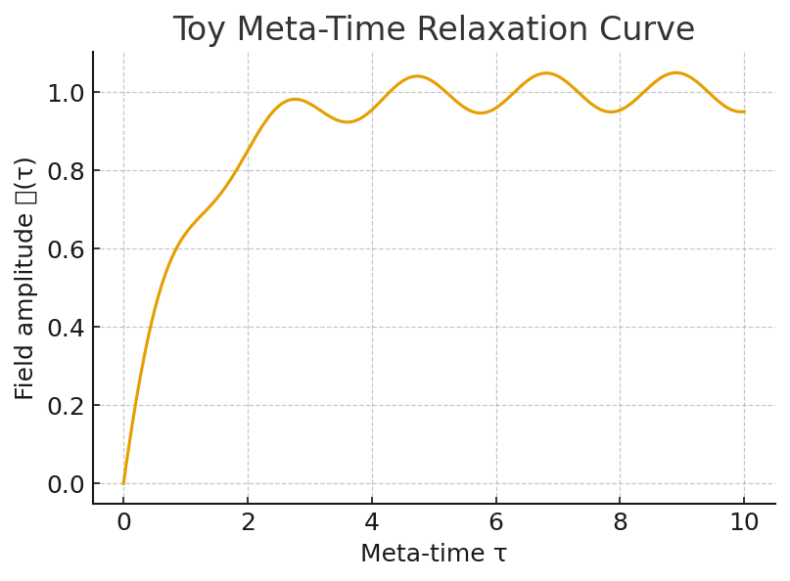
Fig. 3. Toy meta-time relaxation curve showing the approach of 𝒢(τ) toward the condensed vacuum after τ_c.
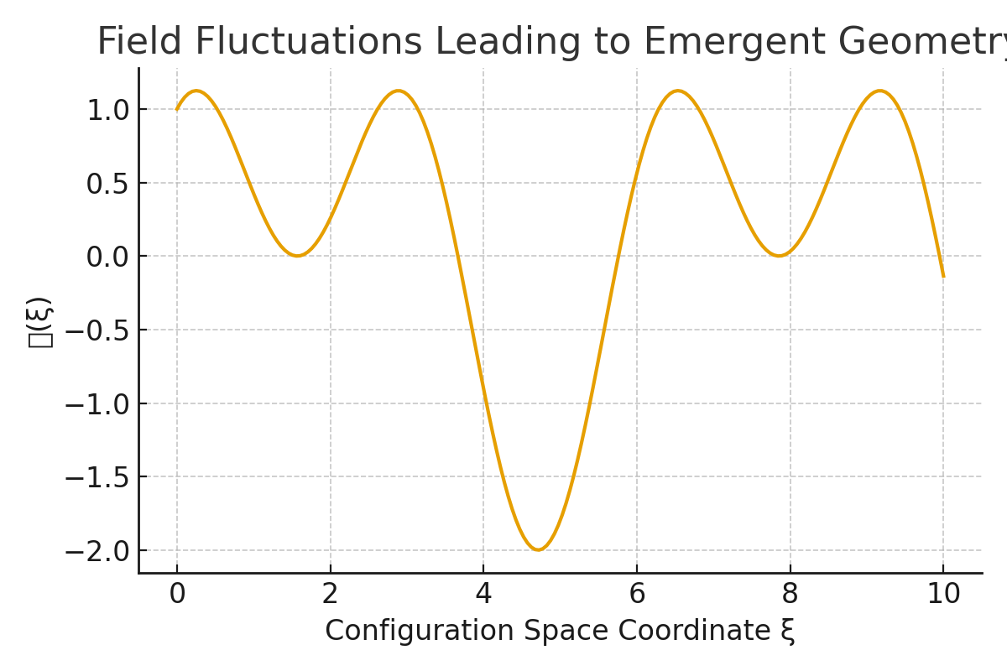
Fig. 4. Emergent spacetime diagram illustrating reconstruction of metric structure from correlation kernels.
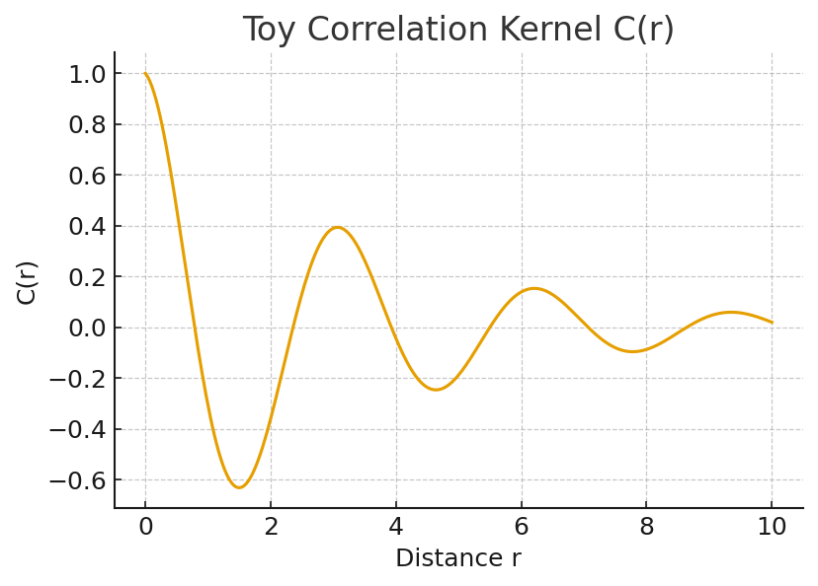
Fig. 5. Toy correlation kernel C(r) whose smoothness encodes emergent geometric information.
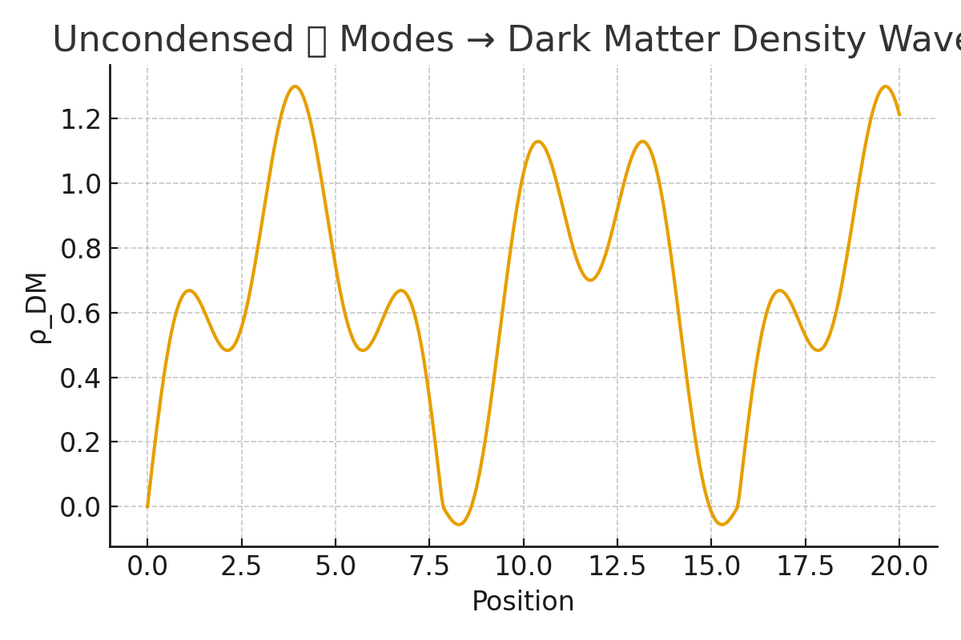
Fig. 6. Diagram showing matter fields emerging from spectral clusters of eigenmodes χₖ.
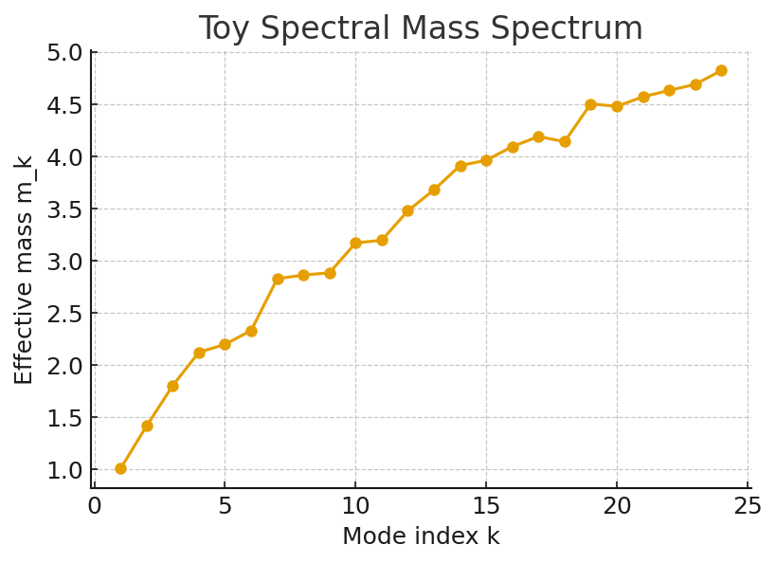
Fig. 7. Toy mass spectrum mₖ derived from eigenvalues λₖ, illustrating hierarchical mass generation.
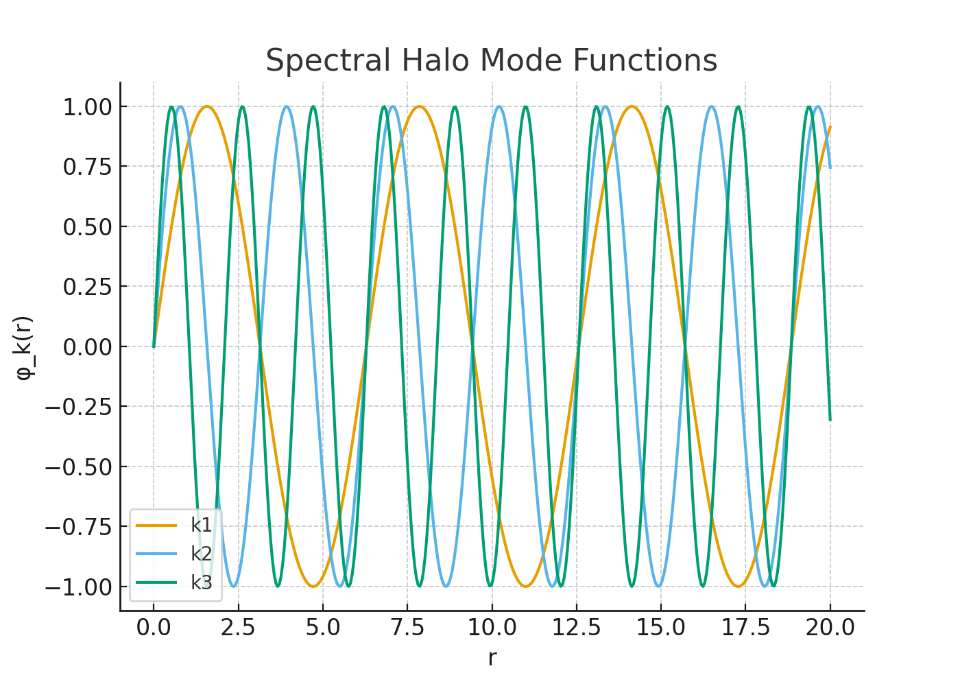
Fig. 8. Halo mode structure generated by long-wavelength modes, producing cored and oscillatory halos.
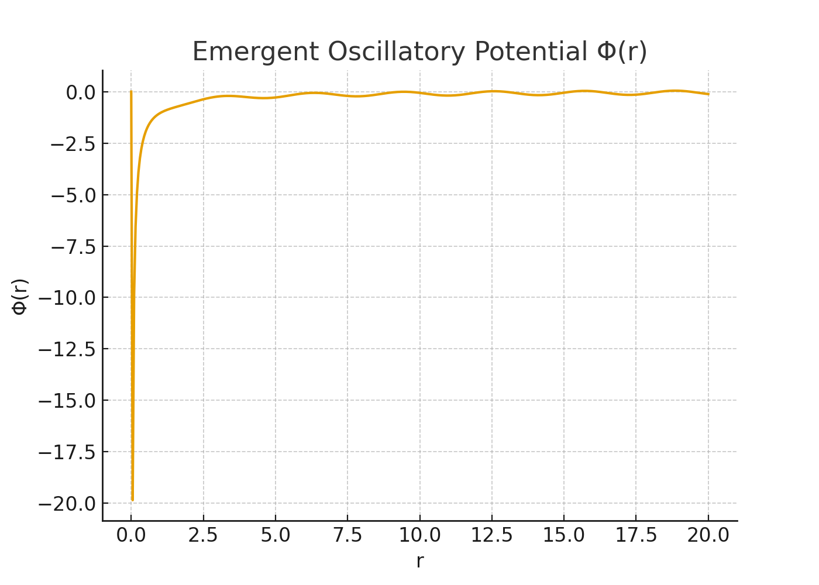
Fig. 9. Radial mode profile ϕ(r) with oscillatory standing-wave structure in radius.
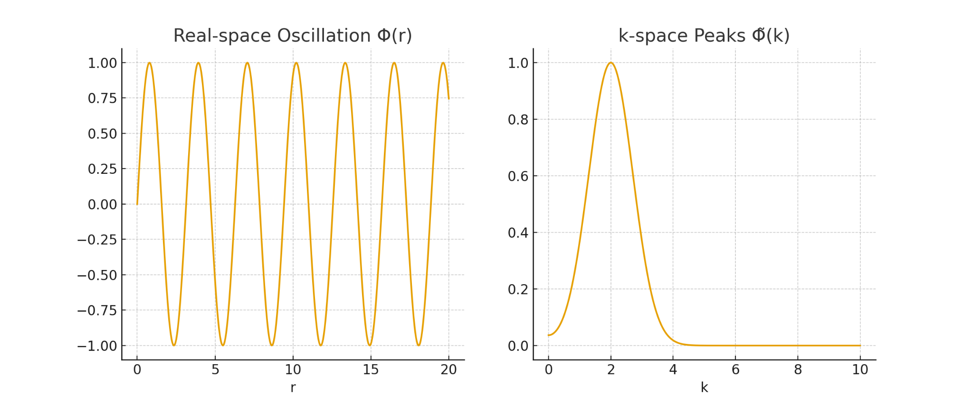
Fig. 10. Duality between Δρ(r) and Δρ(k), showing how oscillatory real-space structure maps to oscillatory P(k).
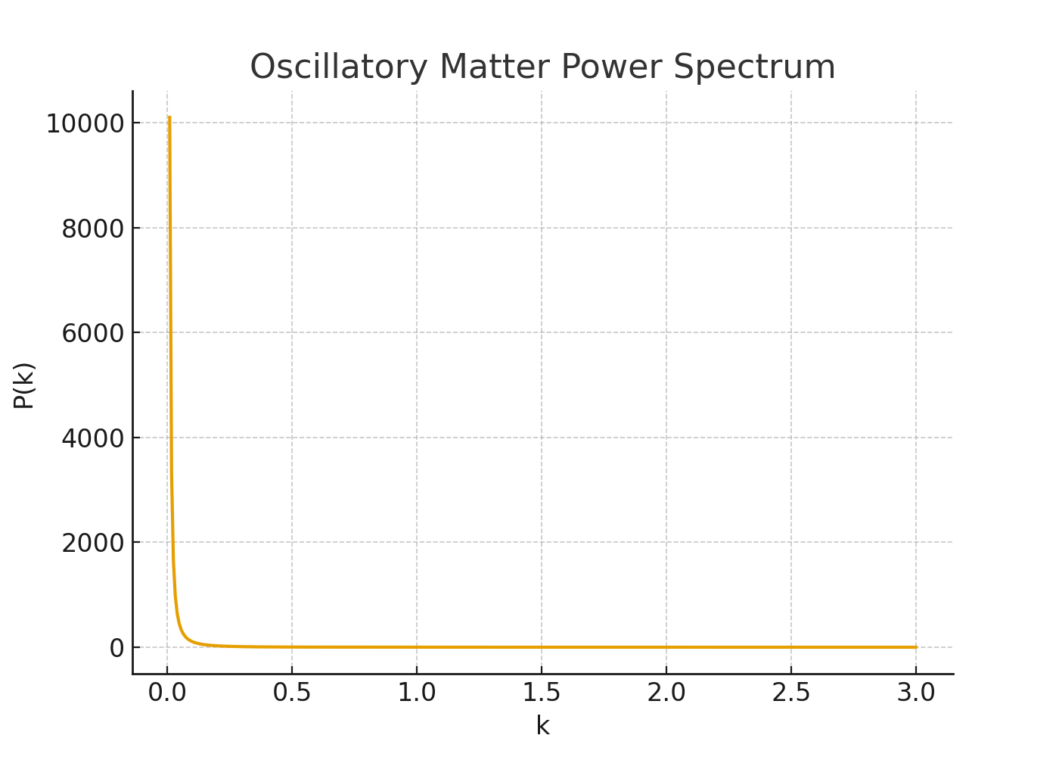
Fig. 11. Oscillatory matter power spectrum P(k) predicted by the discrete spectrum of Ô in GenesisFT.
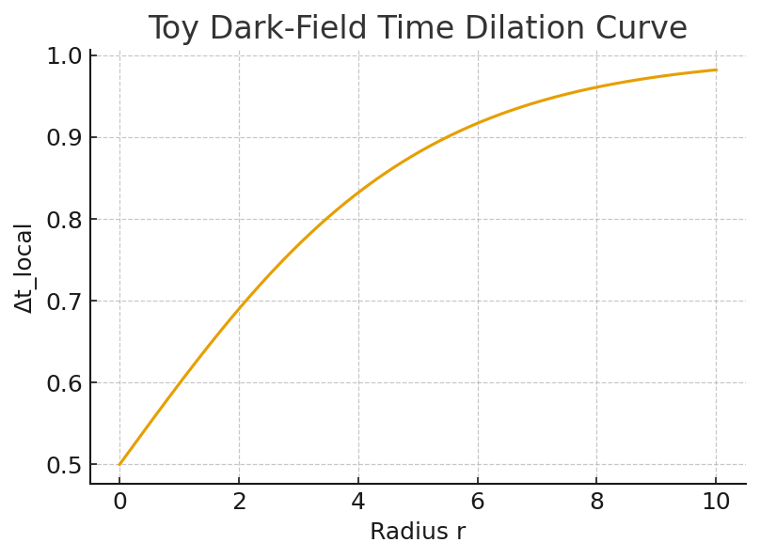
Fig. 12. Toy mid-band dark-matter time-dilation curve with Δt_local ∝ (1 + ρ_DF)^{-1}.
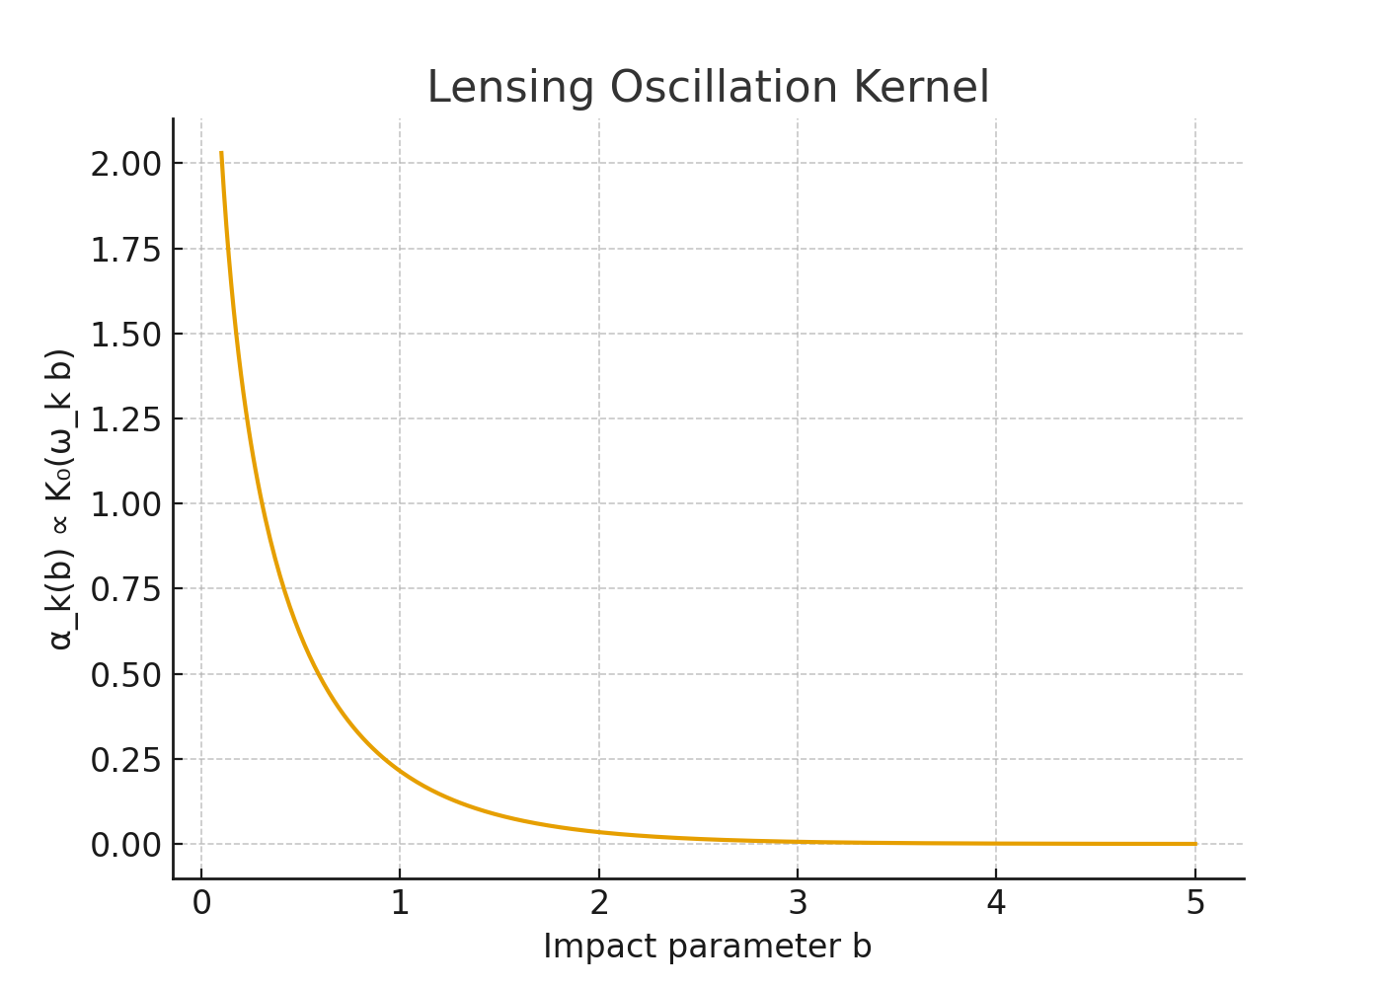
Fig. 13. Lensing kernel demonstrating how mid-band dark-matter density modulates deflection angles.
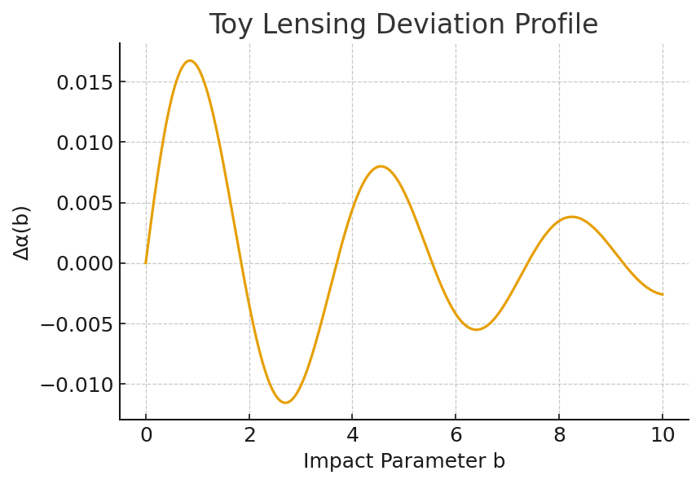
Fig. 14. Toy lensing deviation profile illustrating oscillatory corrections to α(b).
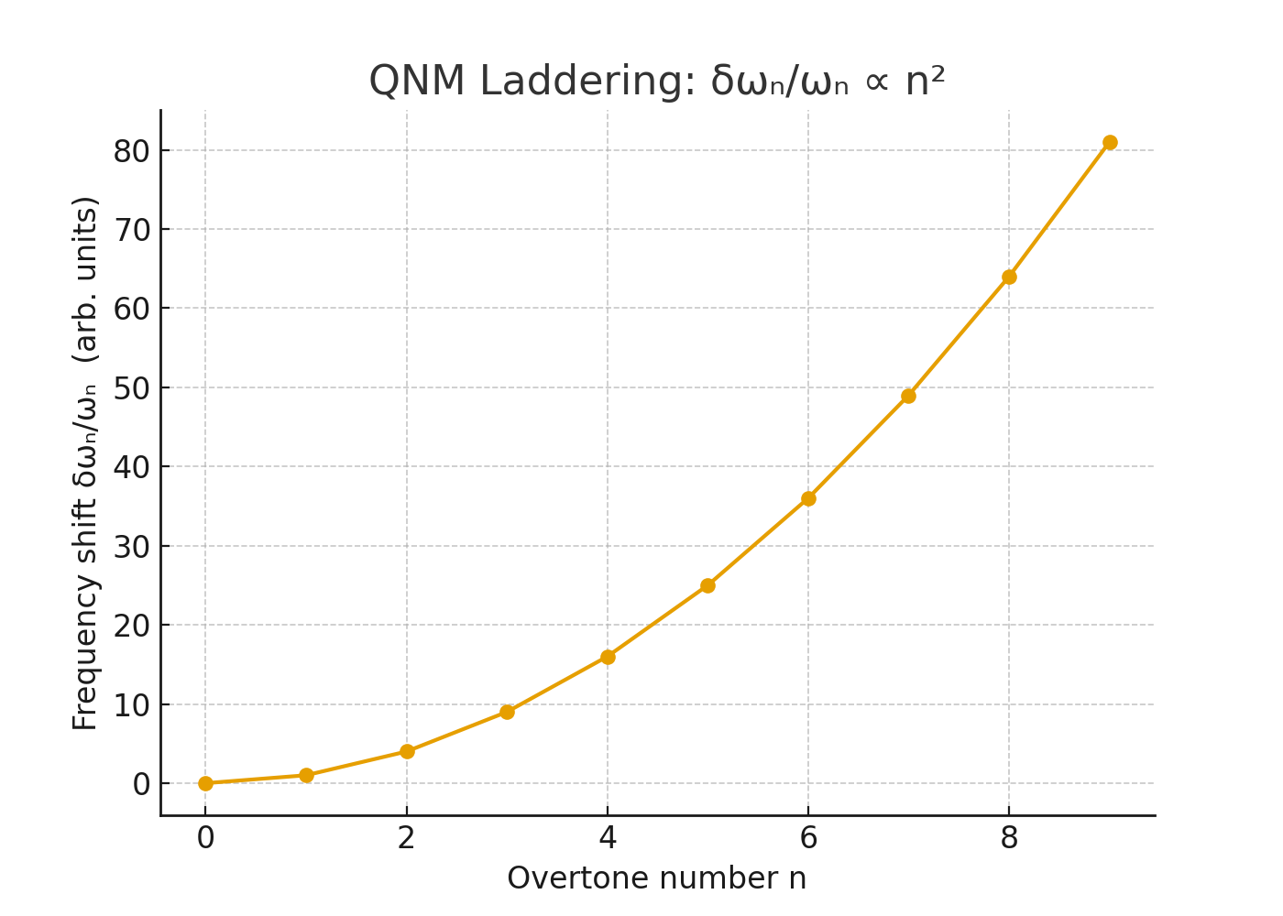
Fig. 15. Quasi-normal mode ladder relevant for post-merger ringdown spectra.
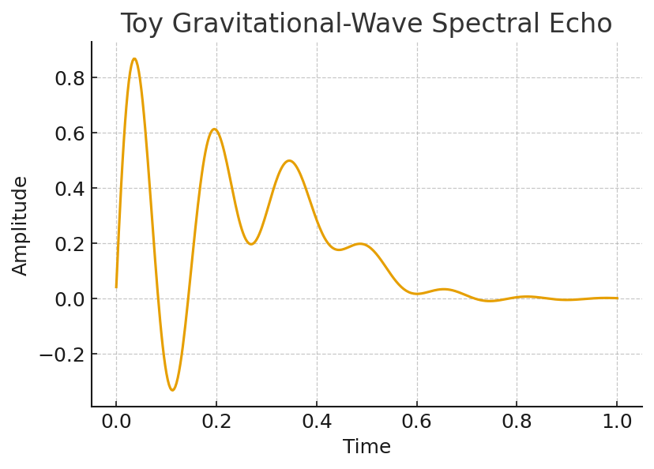
Fig. 16. Toy gravitational-wave spectral echo signal arising from interference of discrete modes.
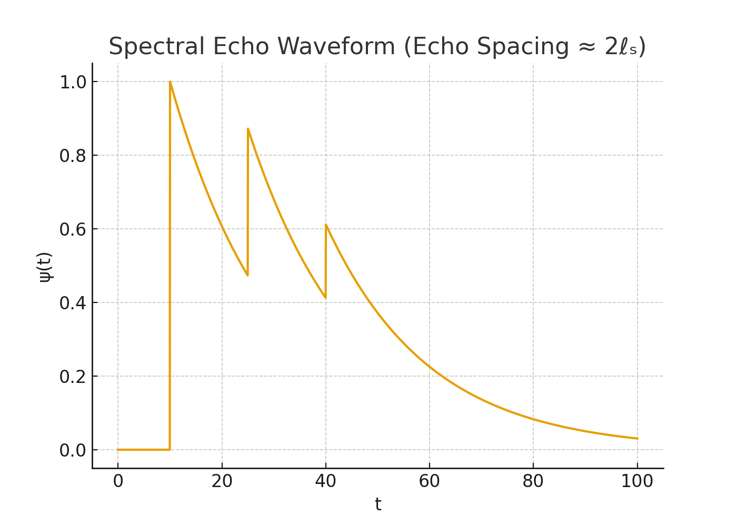
Fig. 17. Conceptual observed echo waveform qualitatively consistent with GenesisFT spectral predictions.
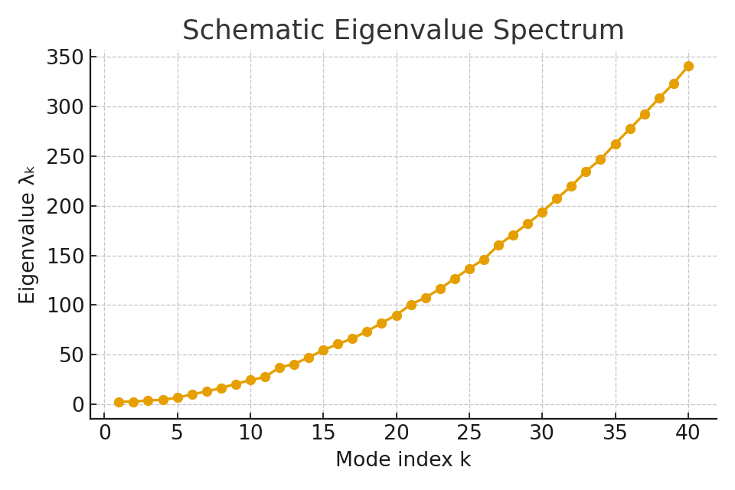
Fig. A1. Schematic eigenvalue spectrum λₖ in Appendix A, illustrating the assumed spectral backbone.
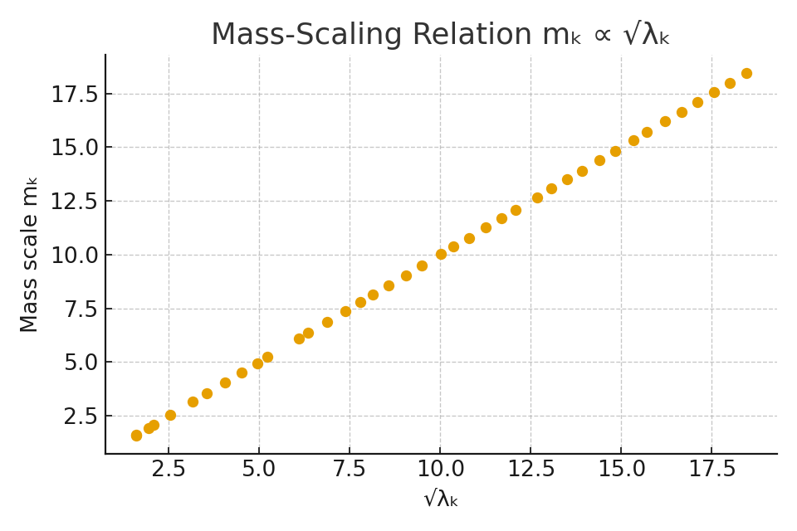
Fig. A2. Mass-scaling relation mₖ ∝ √λₖ for Appendix A, tying spectral scales to effective masses.

References
1. S. Weinberg, Cosmology, Oxford University Press (2008).
2. V. Mukhanov, Physical Foundations of Cosmology, Cambridge University Press (2005).
3. R. M. Wald, General Relativity, University of Chicago Press (1984).
4. J. D. Bekenstein, "Black holes and entropy," Phys. Rev. D 7, 2333 (1973).
5. S. W. Hawking, "Particle creation by black holes," Commun. Math. Phys. 43, 199–220 (1975).
6. A. Connes, Noncommutative Geometry, Academic Press (1994).
7. J. F. Navarro, C. S. Frenk, S. D. M. White, "A Universal Density Profile from Hierarchical Clustering," Astrophys. J. 490, 493 (1997).
8. W. J. G. de Blok, "The core-cusp problem," Adv. Astron. 2010, 789293 (2010).
9. E. Berti et al., "Testing General Relativity with Present and Future Astrophysical Observations," Class. Quantum Grav. 32, 243001 (2015).
10. V. Cardoso et al., "Gravitational-wave signatures of exotic compact objects and of quantum corrections at the horizon scale," Phys. Rev. D 94, 084031 (2016).
11. N. Arkani-Hamed et al., "The cosmological bootstrap," JHEP 02, 049 (2020).
12. D. Oriti, "The microscopic dynamics of quantum space as a group field theory," in Foundations of Space and Time, Cambridge University Press (2012).

